Happy New Year from the Institute of Grace. We pray your new year is off to a rousing start.
In just over a week I will be leading the first of six sessions with the University de la Grace students in Merger. This church leader training program will over 200 hours of instruction in a broad range of topics related to Scripture and the Christian church. We begin with basic doctrine and the character of God.
This is an attempt to restart the work of the University de la Grace after an extended dormant period following the earthquake. I am looking forward to meeting the 20 or so students for the first time. I will be returning in April, May, June, September, and November for the balance of the course. I’d love to have you along if you would like to see the work being done in Merger.
The Primary School continues to feed and educate over 100 children and work on the 3rd floor of the main building is progressing, so opportunities to interact go well beyond the Universite classes.
If you would like to support the Church Leader Training, or any other aspect of the IOG, we welcome your support. It is a personal blessing to be able to go so often and see the difference your contributions are making. Yearend giving statements have been sent, so let me know if you didn’t get yours. Contributions can be mailed to (we also have an online giving option on the IOG website):
Institute of Grace (InstituteofGrace.org)
P.O. Box 2364
Leesburg, VA 20176

Please pray for me and the work of these dedicated church leaders as we gather Feb 13-20.

David Graves January 30, 2017

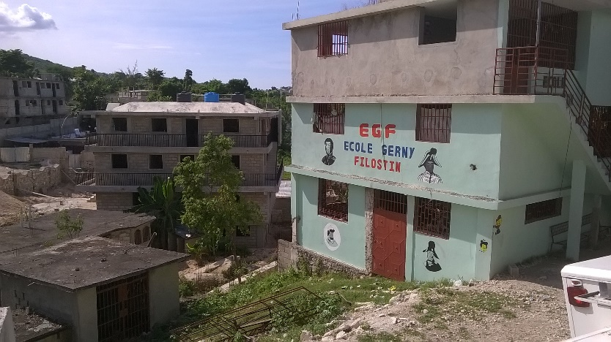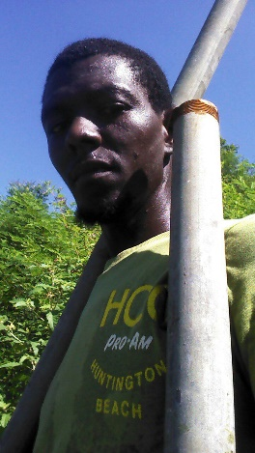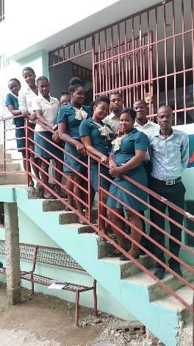
The School building and guest house (background). Eric working on a fence. The school staff.

I will bring back pictures of the University students and the progress on the main building. dpg

